**AI BASED THREAT INTELLIGENCE PLATFORM - REPORT**

<https://github.com/imharshitaa/AI-based-Threat-Intelligence-Platform-Project>

<https://github.com/imharshitaa/AI-cybersecurity-course-work>

Student ID: SB20230728057

Name: Harshitaa Ashish

VIT Bhopal | 21BCY10123 | [harshitaa.ashish2021@vitbhopal.ac.in](mailto:harshitaa.ashish2021@vitbhopal.ac.in) | 9895642902

Overview:

Build a platform that gathers and analyses threat intelligence data from various sources, providing actionable insights to users.

INTRODUCTION:

Building an AI-Based Threat Intelligence Platform: In an era marked by an ever-expanding digital landscape and increasingly sophisticated cyber threats, the need for robust and intelligent cybersecurity solutions has never been more pressing. The "AI-Based Threat Intelligence Platform" project is a pioneering endeavor that seeks to fortify organizations' defenses against a multitude of cyber adversaries. By harnessing the power of artificial intelligence, this platform aims to provide real-time threat detection, rapid incident response, and proactive defense mechanisms to safeguard critical assets and data.

Challenges: Cyber threats have become more diverse and elusive, with attackers employing advanced techniques to infiltrate systems, steal sensitive data, disrupt operations, and exploit vulnerabilities. Traditional security measures are often insufficient in the face of these evolving threats, necessitating a proactive, adaptive, and intelligence-driven approach.

Vision: This project envisions an AI-based Threat Intelligence Platform that not only identifies known threats but also uncovers emerging and zero-day threats before they can inflict harm. By collecting, normalizing, and analysing vast quantities of data from various sources, the platform will provide an all-encompassing view of an organization's threat landscape. Using advanced machine learning algorithms, it will separate benign anomalies from malicious activities and enable rapid incident response, ultimately empowering organizations to stay one step ahead of cyber adversaries.

Significance: The AI-Based Threat Intelligence Platform stands to redefine the landscape of cybersecurity by offering a proactive defence strategy, enhanced visibility, and the ability to swiftly respond to threats, reducing the risk of data breaches, financial losses, and reputational damage for organizations of all sizes and sectors.

PROBLEM STATEMENT:

In today's rapidly evolving digital landscape, organizations face an escalating and ever-diversifying range of cyber threats. Traditional cybersecurity measures are no longer sufficient to protect against sophisticated attacks. The challenge lies in the need for a comprehensive, real-time, and adaptive threat intelligence platform capable of proactively detecting, analyzing, and responding to emerging and known threats. This project aims to address this critical need by developing an AI-Based Threat Intelligence Platform that empowers organizations to strengthen their cybersecurity defenses and safeguard sensitive data in an environment fraught with constantly evolving cyber threats.

IDEATION:

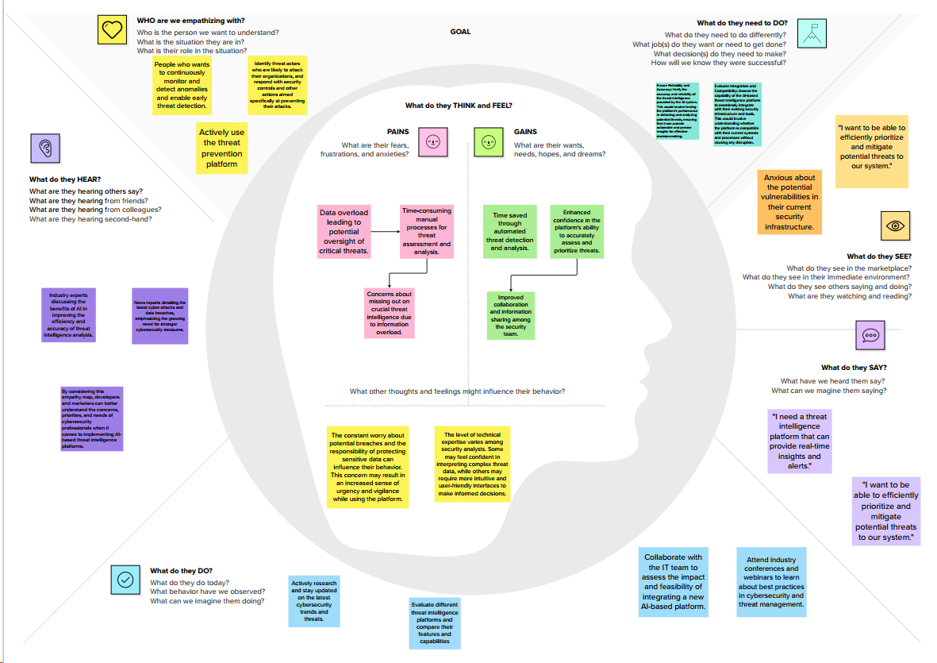

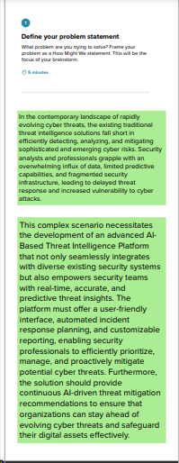 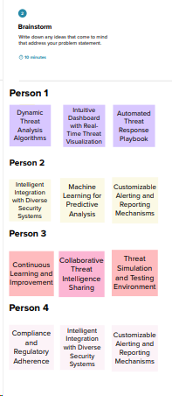

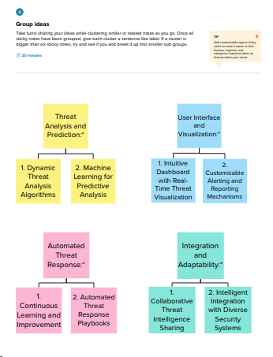 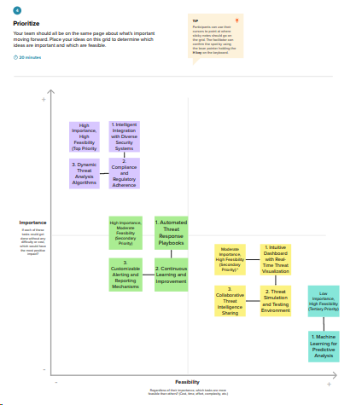

PROPOSED SOLUTION:

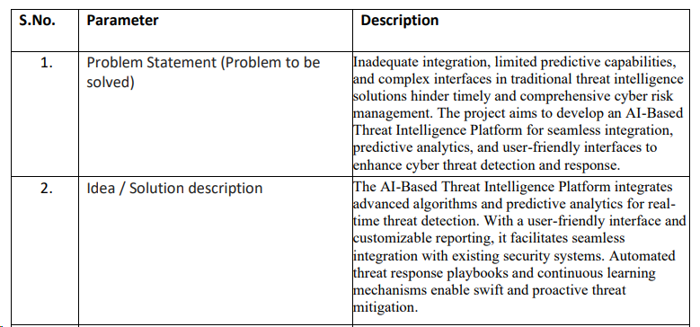

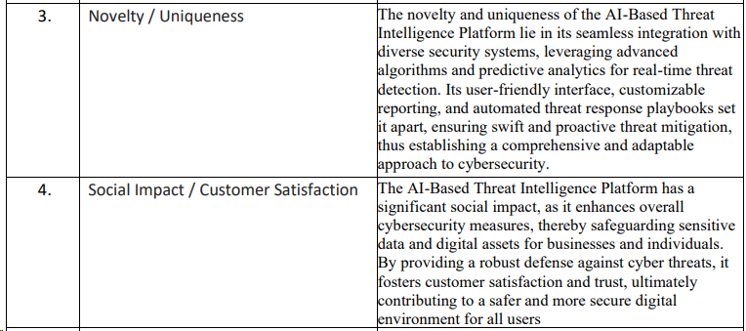

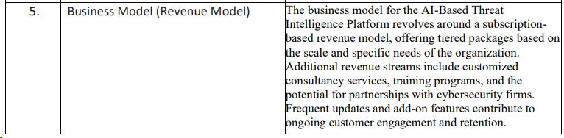

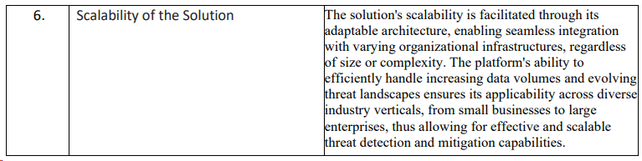

REQUIREMENTS ANALYSIS:

* Data Sources Identification: Define the data sources, including logs, events, and external feeds, to be integrated.
* Machine Learning Models: Specify the ML algorithms and techniques for real-time threat detection.
* Threat Feed Integration: Identify the sources and mechanisms for threat intelligence feeds.
* Real-Time Monitoring: Define parameters for continuous data monitoring and analysis.
* Alerting System: Specify criteria and notification methods for threat alerts.
* Incident Response Integration: Describe integration points with incident response processes.
* User Interface: Detail design and reporting requirements for the user interface.
* Security and Compliance: Specify security measures and compliance with regulations.
* Testing and Validation: Define testing methods and criteria for platform validation.
* Budget and Timeline: Establish resource allocation and project timeline for successful development and implementation.

PROJECT DESIGN:

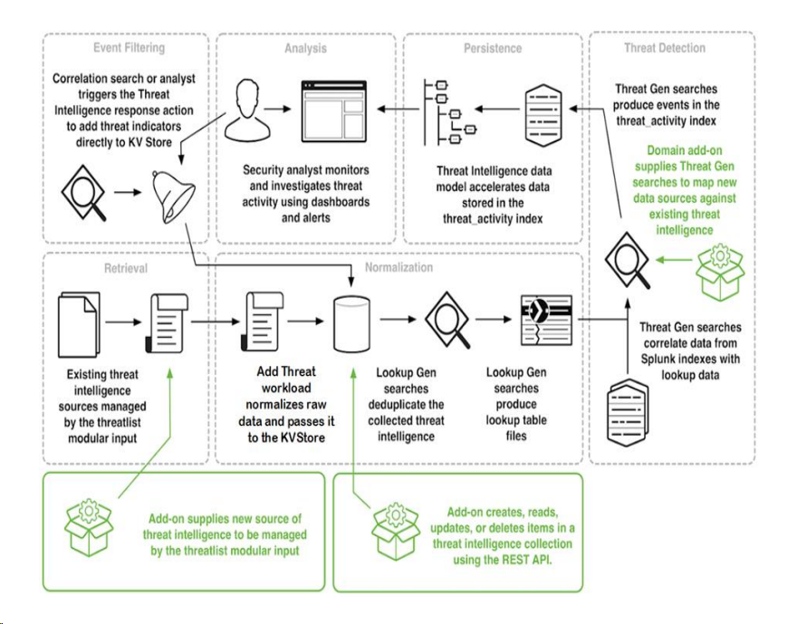

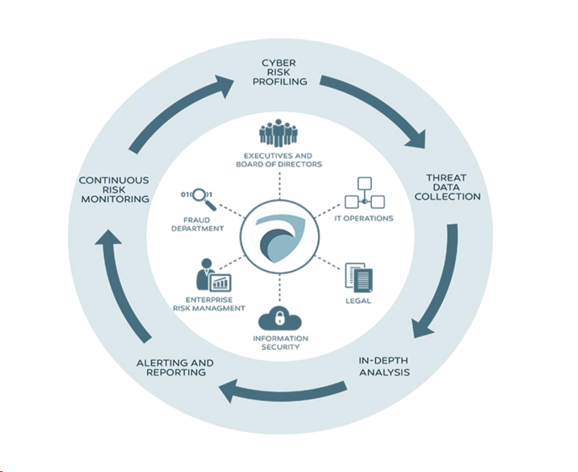

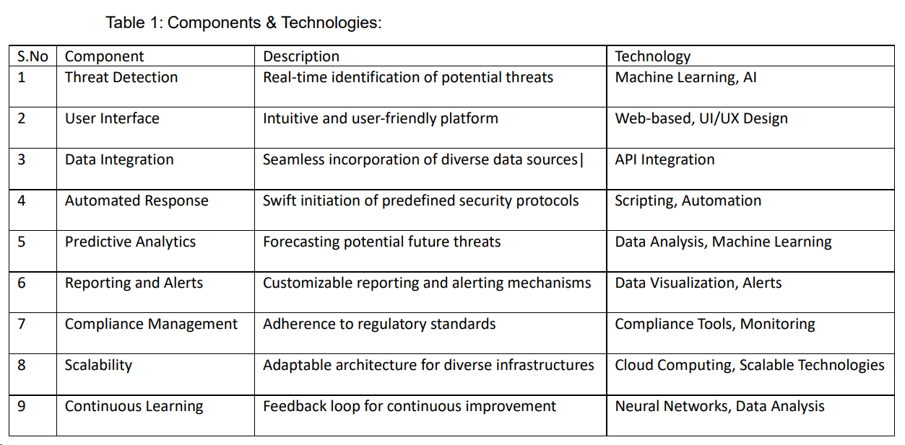

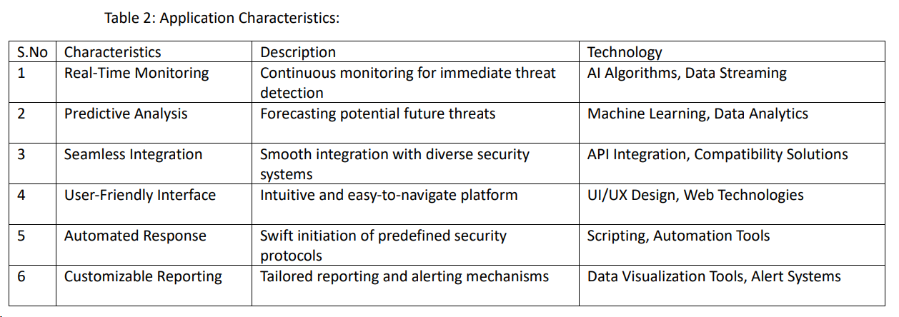

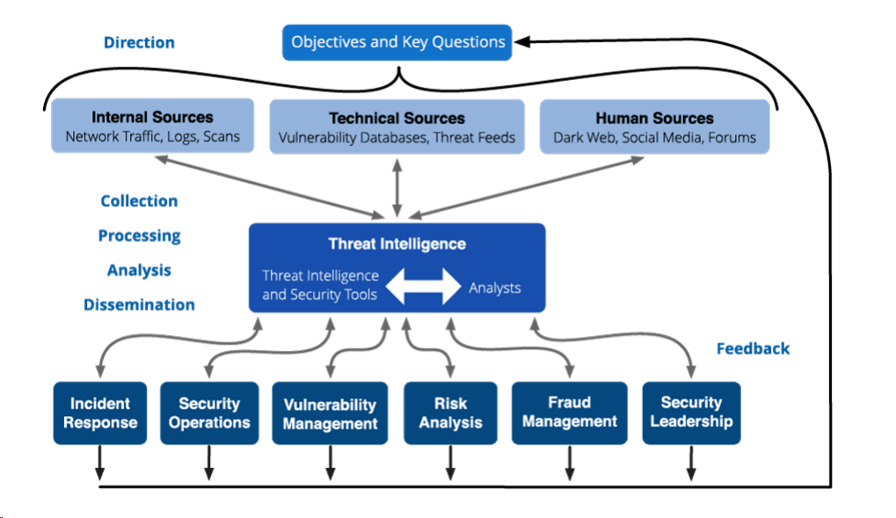

PROJECT PLANNING:

* Project Objectives: Clearly define the project's goals, including what the AI-Based Threat Intelligence Platform aims to achieve.
* Scope Definition: Determine the boundaries of the project, specifying what is included and what is not, to manage expectations.
* Team Formation: Assemble a multidisciplinary team with the necessary expertise in cybersecurity, machine learning, software development, and UI/UX design.
* Timeline and Milestones: Develop a project schedule with key milestones and deadlines, ensuring that tasks are sequenced effectively.
* Resource Allocation: Allocate resources, including budget, personnel, and technology infrastructure, to support the project.
* Risk Assessment: Identify potential risks and create mitigation strategies to minimize project disruptions.
* Communication Plan: Establish a clear communication plan to keep stakeholders informed and engaged throughout the project's lifecycle.
* Quality Assurance: Implement testing and quality assurance procedures to ensure the platform's functionality and security.
* Documentation and Training: Develop comprehensive documentation and training programs for platform users and administrators.
* Monitoring and Feedback: Set up systems for continuous monitoring and feedback collection to improve the platform over time and adapt to emerging threats and challenges.

METHODOLOGY:

* Initiation: Define project scope, objectives, and assemble a project team.
* Requirements: Identify organizational needs, data sources, and threat types.
* Data Collection: Set up data pipelines for gathering and storing data.
* Model Development: Create machine learning models for threat detection.
* Real-Time Analysis: Implement real-time analysis and alerting.
* Threat Feeds: Integrate external threat intelligence feeds for context.
* User Interface: Design a user-friendly dashboard for analysts.
* Automation: Automate response for common threats.
* Integration: Integrate with existing security tools and systems.
* Testing and Deployment: Test, fine-tune, and deploy the platform.

PERFORMANCE TESTING:

* Load Testing: Assess how the platform performs under expected and peak loads.
* Stress Testing: Evaluate system robustness under extreme loads to uncover bottlenecks and vulnerabilities.
* Scalability Testing: Measure the platform's ability to handle increasing data and user traffic as it scales.
* Latency Testing: Analyze response times to ensure real-time capabilities for threat detection.
* Throughput Testing: Determine the transaction capacity within a given timeframe.
* Concurrent User Testing: Assess support for multiple simultaneous users and requests.
* Peak Load Testing: Evaluate performance at maximum capacity to ensure uninterrupted service during high-demand periods.
* Endurance Testing: Run the platform over an extended period to identify memory leaks or performance degradation.
* Failover Testing: Verify the platform's ability to switch to backup systems in case of failures.
* Security and Usability Testing: Evaluate performance under security threats and examine the impact of the user interface on overall system performance.

RESULTS:

Load and Scalability Data: Metrics on how the platform performs under different loads, including response times and resource utilization.

Stress Test Findings: Identification of system weaknesses and bottlenecks under extreme loads for targeted improvements.

Latency Metrics: Insights into response times crucial for real-time threat detection.

Throughput Analysis: Information on the platform's transaction capacity within specific timeframes.

Failover Effectiveness: Confirmation of the system's ability to switch to backup systems in case of failures, enabling continuous service.

ADVANTAGES AND DISADVANTAGES:

|  |  |
| --- | --- |
| Advantages | Disadvantages |
| Identifies system bottlenecks and weaknesses. | Resource-intensive and time-consuming. |
| Ensures the system can handle expected loads. | May not capture all real-world scenarios. |
| Helps optimize resource allocation. | Test environments may not mirror production. |
| Detects memory leaks and performance degradation. | Requires skilled testers and tools. |
| Validates real-time capabilities for threat detection. | May not uncover all security vulnerabilities. |

CONCLUSION:

The AI-Based Threat Intelligence Platform is a dynamic solution that will continue to shape the future of cybersecurity. By leveraging advanced machine learning, automation, and the capability to adapt to emerging challenges, the platform offers a proactive defense strategy. It is poised to expand into new frontiers, addressing IoT and cloud security, implementing predictive analytics, and ensuring global compliance. As the cybersecurity landscape evolves, this platform stands ready to empower organizations, reduce data breach risks, and provide a robust line of defense against an ever-adapting spectrum of cyber threats.

FUTURE SCOPE:

* Advanced Machine Learning: Evolve machine learning models to stay ahead of emerging cyber threats and enhance threat detection accuracy.
* Automation: Expand automation capabilities for faster threat response, reducing manual intervention.
* IoT and Cloud Security: Extend coverage to address IoT and cloud security challenges as these domains grow in importance.
* Predictive Analysis: Develop predictive analytics to proactively identify potential threats based on historical data and emerging trends.
* Global Reach and Compliance: Broaden the platform's global footprint, ensuring it complies with evolving data protection regulations and cybersecurity needs worldwide.

APPENDIX:

<https://github.com/imharshitaa/AI-based-Threat-Intelligence-Platform-Project>